Dimension and Fact Tables Construction

**Provide code and screenshots of loading the data into the dimensions and the fact. Currently, you do not need to worry about maintenance of slowly changing dimensions, the focus is on the initial data load. If you are loading into SCD2 or SCD3, make sure to show the SCD maintenance attributes populated.**

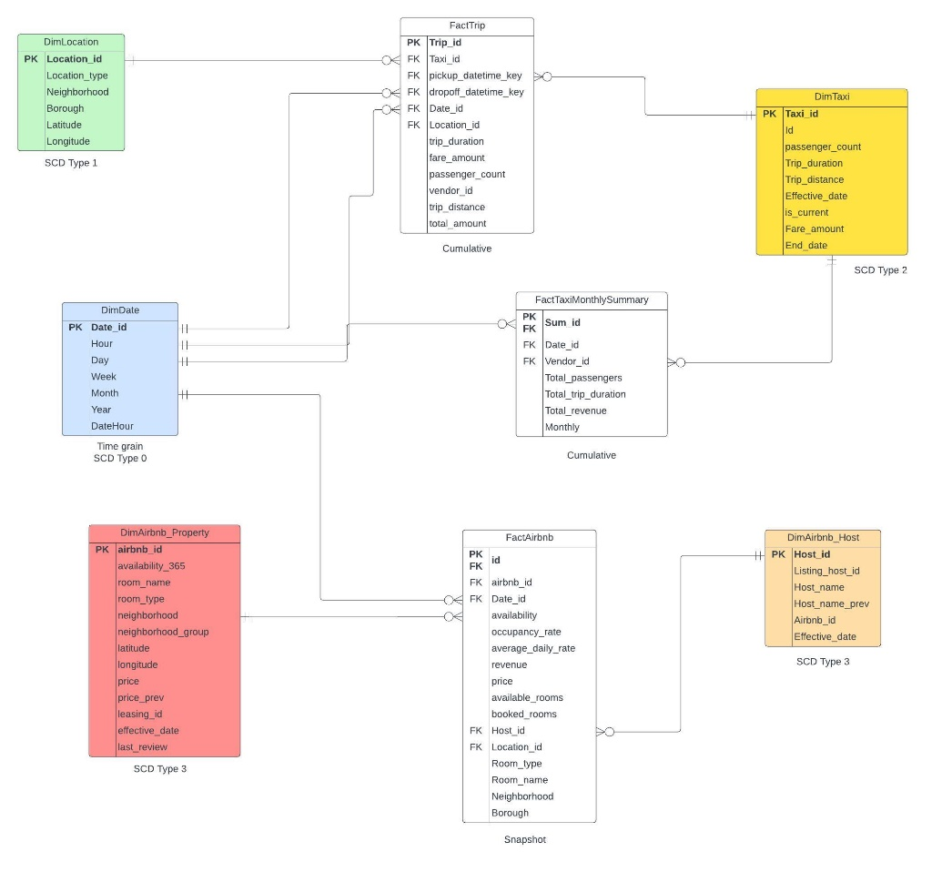

**Staging**

ALTER TABLE Taxi_staging ADD taxi_datetime DATETIME;

UPDATE Taxi_staging

SET taxi_datetime = DATEADD(HOUR, DATEDIFF(HOUR, 0, dropoff_datetime), 0);

(The purpose of adding taxi_datetime is to help create the monthly function in FactTaxiMonthlySummary)

**Dimension**

1. DimAirbnb_Property

-- Create DimAirbnb_Property

CREATE TABLE DimAirbnb_Property (

Airbnb_id INT IDENTITY(1,1) PRIMARY KEY,

Leasing_id INT,

Room_name NVARCHAR(255),

Room_type NVARCHAR(50),

Price INT,

Neighborhood NVARCHAR(255),

Neighborhood_group NVARCHAR(255),

Latitude DECIMAL(9,6),

Longitude DECIMAL(9,6),

Availability_365 INT,

Price_prev INT

);

-- Insert data into DimAirbnb_Property

INSERT INTO DimAirbnb_Property (Airbnb_id, Room_name, Room_type, Price, Neighborhood, Neighborhood_group, Latitude, Longitude, Availability_365)

SELECT airbnb_id, name, room_type, price, neighborhood, neighborhood_group, latitude, longitude, availability_365

FROM Airbnb_staging;

2. DimAirbnb_Host

-- Create DimAirbnb_Host

CREATE TABLE DimAirbnb_Host (

Host_id INT IDENTITY(1,1) PRIMARY KEY,

Listing_host_id INT,

Host_name NVARCHAR(255),

Host_name_prev NVARCHAR(255)

);

-- Insert data into DimAirbnb_Host

INSERT INTO DimAirbnb_Host (Listing_host_id, Host_name)

SELECT DISTINCT host_id, host_name

FROM Airbnb_staging;

3. DimDate

CREATE TABLE DimDate (

Date_id INT IDENTITY(1,1) PRIMARY KEY,

DateHour DATETIME NOT NULL,

Hour INT NOT NULL,

Day INT NOT NULL,

Month INT NOT NULL,

Year INT NOT NULL,

Week INT NOT NULL

);

WITH DateRange (DateHour) AS (

SELECT CAST('2010-01-01 00:00:00' AS DATETIME)

UNION ALL

SELECT DATEADD(hour, 1, DateHour)

FROM DateRange

WHERE DateHour < '2023-12-31 23:00:00'

)

INSERT INTO DimDate (DateHour, Hour, Day, Month, Year, Week)

SELECT

DateHour,

DATEPART(hour, DateHour) AS Hour,

DAY(DateHour) AS Day,

MONTH(DateHour) AS Month,

YEAR(DateHour) AS Year,

DATEPART(wk, DateHour) AS Week

FROM DateRange

OPTION (MAXRECURSION 0);

4. DimLocation

CREATE TABLE DimLocation (

Location_id INT IDENTITY(1,1) PRIMARY KEY,

Location_type VARCHAR(50),

Neighborhood VARCHAR(255),

Borough VARCHAR(255),

Longitude DECIMAL(9, 6),

Latitude DECIMAL(9, 6)

);

INSERT INTO DimLocation (Latitude, Longitude, Location_type)

SELECT DISTINCT

dropoff_latitude,

dropoff_longitude,

'Taxi Dropoff'

FROM Taxi_staging;

(Same process for the Airbnb and Taxi Pickup, the difference is that we also need to consider about the Borough and Neighborhood from Airbnb_staging)

5. DimTaxi

CREATE TABLE DimTaxi (

Taxi_id INT IDENTITY(1,1) NOT NULL,

Id NVARCHAR(255),

Pickup_datetime DATETIME,

Dropoff_datetime DATETIME,

Passenger_count INT,

Trip_distance FLOAT,

pickup_latitude FLOAT,

pickup_longitude FLOAT,

dropoff_latitude FLOAT,

dropoff_longitude FLOAT,

Fare_amount FLOAT,

Effective_date DATE,

End_date DATE,

Is_current BIT

);

INSERT INTO DimTaxi (

Id,

Pickup_datetime,

Dropoff_datetime,

Passenger_count,

Effective_date,

End_date,

Is_current,

pickup_latitude,

pickup_longitude,

dropoff_latitude,

dropoff_longitude

)

SELECT

taxi_id,

Pickup_datetime,

Dropoff_datetime,

Passenger_count,

CAST(GETDATE() AS DATE),

NULL,

1,

pickup_latitude,

pickup_longitude,

dropoff_latitude,

dropoff_longitude

FROM

Taxi_staging;

UPDATE DimTaxi

SET Trip_duration =

CASE

WHEN Taxi_staging.trip_duration IS NOT NULL THEN Taxi_staging.Trip_duration

ELSE DATEDIFF(second, pickup_datetime, dropoff_datetime)

END

FROM DimTaxi

JOIN Taxi_staging ON DimTaxi.Id = Taxi_staging.taxi_id;

UPDATE DimTaxi

SET

trip_distance = CASE

WHEN ts.Trip_duration IS NOT NULL THEN ts.trip_duration * 0.2

ELSE 0

END,

fare_amount = CASE

WHEN ts.Trip_duration IS NOT NULL THEN ts.trip_duration * 0.05 + 10

ELSE 0

END

FROM DimTaxi t

JOIN taxi_staging ts ON t.Id = ts.taxi_id;

**Fact**

FactAirbnb:

-- Create FactAirbnb

CREATE TABLE FactAirbnb (

Id INT IDENTITY(1,1) PRIMARY KEY NOT NULL,

Airbnb_id INT NOT NULL FOREIGN KEY REFERENCES DimAirbnb_Property(Airbnb_id),

Date_id INT NOT NULL FOREIGN KEY REFERENCES DimDate(Date_id),

Host_id INT NOT NULL FOREIGN KEY REFERENCES DimAirbnb_Host(Host_id),

Room_name VARCHAR(300),

Room_type VARCHAR(50),

Neighborhood VARCHAR(100),

Borough VARCHAR(50),

Availability INT,

Price FLOAT,

Revenue FLOAT,

Available_rooms INT,

Booked_rooms INT,

Occupancy_rate FLOAT,

Average_daily_rate FLOAT

);

);

-- Insert data into FactAirbnb

INSERT INTO FactAirbnb (Airbnb_id, Date_id, Host_id, Room_name, Room_type, Neighborhood, Borough, Availability, Price, Revenue, Occupancy_rate, Average_daily_rate)

SELECT

p.Airbnb_id,

d.Date_id,

h.Host_id,

p.Room_name,

p.Room_type,

p.Neighborhood,

p.Neighborhood_group,

p.Availability_365,

p.Price,

p.Price * p.Availability_365 AS Revenue,

NULL AS Occupancy_rate,

NULL AS Average_daily_rate

FROM

DimAirbnb_Property p

INNER JOIN DimDate d ON CAST(p.last_review AS DATE) = CAST(d.DateHour AS DATE)

INNER JOIN DimAirbnb_Host h ON p.Leasing_id = h.airbnb_id;

UPDATE FactAirbnb

SET

available_rooms = Availability / 365,

booked_rooms = (365 - Availability) / 365

UPDATE FactAirbnb

SET Occupancy_rate = CASE WHEN Availability > 0 THEN (365-Availability)/365 ELSE 0 END,

Average_daily_rate = CASE WHEN Availability > 0 THEN Revenue/Availability ELSE 0 END;

ALTER TABLE FactAirbnb

ADD Location_id INT;

UPDATE FactAirbnb

SET location_id = (

SELECT TOP 1 location_id

FROM DimLocation

WHERE Location_type = 'Airbnb'

AND Neighborhood = FactAirbnb.Neighborhood

AND Borough = FactAirbnb.Borough

);

--- Current in use

UPDATE FactAirbnb

SET

Availability = p.availability_365 / 365.0,

Revenue = p.availability_365 * p.price,

Available_rooms = p.availability_365,

Booked_rooms = 365 - p.availability_365,

Occupancy_rate = (365 - p.availability_365) / 365.0,

Average_daily_rate = (

SELECT AVG(price)

FROM DimAirbnb_Property

WHERE Airbnb_id = FactAirbnb.Id

)

FROM DimAirbnb_Property p

WHERE p.Airbnb_id = FactAirbnb.Id;

FactTaxiMonthlySummary:

CREATE TABLE FactTaxiMonthlySummary (

Sum_id INT IDENTITY(1,1) PRIMARY KEY NOT NULL,

Date_id INT NOT NULL,

Taxi_id INT NOT NULL,

Total_passengers INT,

Total_trip_duration FLOAT,

Total_revenue FLOAT,

Monthly INT,

Vendor_id INT

);

INSERT INTO FactTaxiMonthlySummary (Date_id, Taxi_id, Total_passengers, Total_trip_duration, Total_revenue, Monthly)

SELECT

d.Date_id,

tx.Taxi_id,

SUM(tx.Passenger_count) AS Total_passengers,

SUM(tx.Trip_duration) AS Total_trip_duration,

SUM(tx.Fare_amount) AS Total_revenue,

FORMAT(d.DateHour, 'yyyy-MM') AS Monthly

FROM

DimTaxi tx

JOIN Taxi_staging t ON t.taxi_id = tx.Id

JOIN DimDate d ON CAST(t.taxi_datetime AS DATE) = CAST(d.DateHour AS DATE)

GROUP BY

d.Date_id,

tx.Taxi_id,

FORMAT(d.DateHour, 'yyyy-MM');

ALTER TABLE FactTrip

ALTER COLUMN Pickup_datetime_key DATETIME;

ALTER TABLE FactTrip

ALTER COLUMN Dropoff_datetime_key DATETIME;

FactTrip:

CREATE TABLE FactTrip (

Trip_id INT IDENTITY(1,1) PRIMARY KEY NOT NULL,

Taxi_id INT NOT NULL,

Location_id INT NOT NULL,

Date_id INT NOT NULL,

Pickup_datetime_key INT,

Dropoff_datetime_key INT,

Pickup_location INT,

Dropoff_location INT,

Passenger_count INT,

Trip_distance FLOAT,

Trip_duration INT,

Fare_amount FLOAT,

Total_amount FLOAT

);

INSERT INTO FactTrip (Taxi_id, Location_id, Date_id, Pickup_datetime_key, Dropoff_datetime_key, Passenger_count, Trip_distance, Trip_duration, Fare_amount, Vendor_id)

SELECT DISTINCT

tx.Taxi_id,

l.Location_id,

d.Date_id,

ts.pickup_datetime,

ts.dropoff_datetime,

tx.Passenger_count,

tx.Trip_distance,

tx.Trip_duration,

tx.Fare_amount,

ts.vendor_id

FROM

DimTaxi tx

JOIN Taxi_staging ts ON ts.taxi_id = tx.Id

JOIN (

SELECT l1.Location_id, l1.latitude

FROM DimLocation l1

JOIN Taxi_staging ts1 ON ts1.dropoff_latitude = l1.latitude AND l1.Location_type = 'Taxi Dropoff'

UNION

SELECT l2.Location_id, l2.latitude

FROM DimLocation l2

JOIN Taxi_staging ts2 ON ts2.pickup_latitude = l2.latitude AND l2.Location_type = 'Taxi Pickup'

) AS l ON l.latitude = ts.dropoff_latitude OR l.latitude = ts.pickup_latitude

JOIN DimDate d ON CAST(ts.taxi_datetime AS DATE) = CAST(d.DateHour AS DATE)

UNION

SELECT DISTINCT

tx.Taxi_id,

l.Location_id,

d.Date_id,

ts.pickup_datetime,

ts.dropoff_datetime,

tx.Passenger_count,

tx.Trip_distance,

tx.Trip_duration,

tx.Fare_amount,

ts.vendor_id

FROM

DimTaxi tx

JOIN Taxi_staging ts ON ts.taxi_id = tx.Id

JOIN (

SELECT l1.Location_id, l1.longitude

FROM DimLocation l1

JOIN Taxi_staging ts1 ON ts1.dropoff_longitude = l1.longitude AND l1.Location_type = 'Taxi Dropoff'

UNION

SELECT l2.Location_id, l2.longitude

FROM DimLocation l2

JOIN Taxi_staging ts2 ON ts2.pickup_longitude = l2.longitude AND l2.Location_type = 'Taxi Pickup'

) AS l ON l.longitude = ts.dropoff_longitude OR l.longitude = ts.pickup_longitude

JOIN DimDate d ON CAST(ts.taxi_datetime AS DATE) = CAST(d.DateHour AS DATE)

UPDATE FactTrip

SET Total_amount = subquery.Total_amount

FROM (

SELECT Taxi_id, SUM(Fare_amount) as Total_amount

FROM FactTrip

GROUP BY Taxi_id

) AS subquery

WHERE FactTrip.Taxi_id = subquery.Taxi_id;

